Library Management System (.NET NUnit)
Technology: C# (.NET) + NUnit
Name: Tushar Dev Singh

Introduction
This project implements a simple Library Management System with the following features:
- Add new books
- Register borrowers
- Borrow books
- Return books
- View books and borrowers
Unit tests are written using NUnit framework to validate functionality.

Class Implementation
Book.cs:
using System;
using System.Collections.Generic;
using System.Text;

namespace LibraryManagementSystem
{
public class Book
{
public string Title { get; set; }
public string Author { get; set; }
public string ISBN { get; set; }
public bool IsBorrowed { get; private set; }

public Book(string title, string author, string isbn)
{
Title = title;
Author = author;
ISBN = isbn;
IsBorrowed = false;
}

public void Borrow()
{
if (IsBorrowed)
throw new InvalidOperationException("Book already borrowed");

IsBorrowed = true;
}

public void Return()
{
IsBorrowed = false;
}
}
}
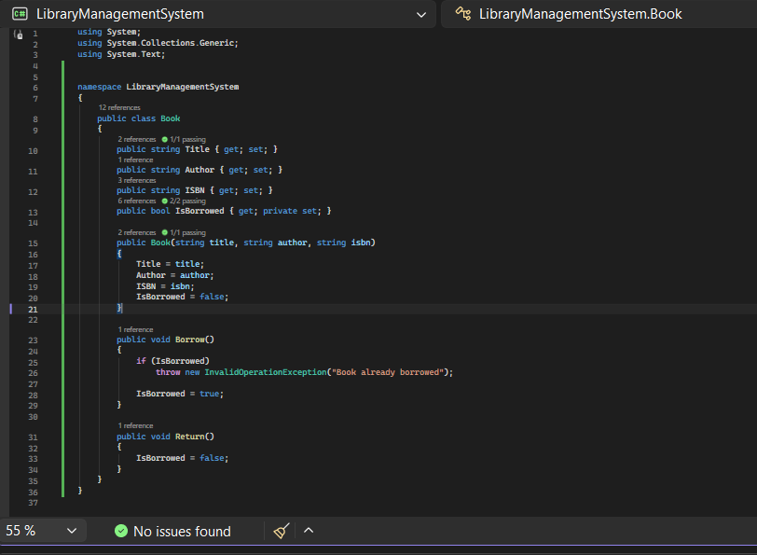

Borrower.cs:
using System.Collections.Generic;

namespace LibraryManagementSystem
{
public class Borrower
{
public string Name { get; set; }
public string LibraryCardNumber { get; set; }
public List<Book> BorrowedBooks { get; private set; }

public Borrower(string name, string cardNumber)
{
Name = name;
LibraryCardNumber = cardNumber;
BorrowedBooks = new List<Book>();
}

public void BorrowBook(Book book)
{
BorrowedBooks.Add(book);
}

public void ReturnBook(Book book)
{
BorrowedBooks.Remove(book);
}
}
}

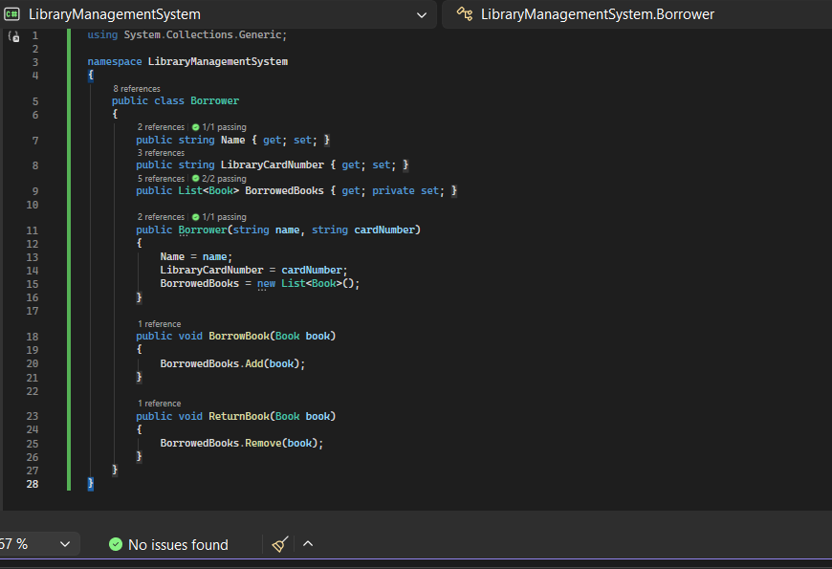

Library.cs:
using System;
using System.Collections.Generic;
using System.Text;
using System.Linq;

namespace LibraryManagementSystem
{
public class Library
{
public List<Book> Books { get; private set; } = new List<Book>();
public List<Borrower> Borrowers { get; private set; } = new List<Borrower>();

public void AddBook(Book book)
{
Books.Add(book);
}

public void RegisterBorrower(Borrower borrower)
{
Borrowers.Add(borrower);
}

public void BorrowBook(string isbn, string cardNumber)
{
var book = Books.FirstOrDefault(b => b.ISBN == isbn);
var borrower = Borrowers.FirstOrDefault(b => b.LibraryCardNumber == cardNumber);

if (book == null || borrower == null)
throw new Exception("Book or borrower not found");

book.Borrow();
borrower.BorrowBook(book);
}

public void ReturnBook(string isbn, string cardNumber)
{
var book = Books.FirstOrDefault(b => b.ISBN == isbn);
var borrower = Borrowers.FirstOrDefault(b => b.LibraryCardNumber == cardNumber);

if (book == null || borrower == null)
throw new Exception("Book or borrower not found");

book.Return();
borrower.ReturnBook(book);
}

public List<Book> ViewBooks()
{
return Books;
}

public List<Borrower> ViewBorrowers()
{
return Borrowers;
}
}
}

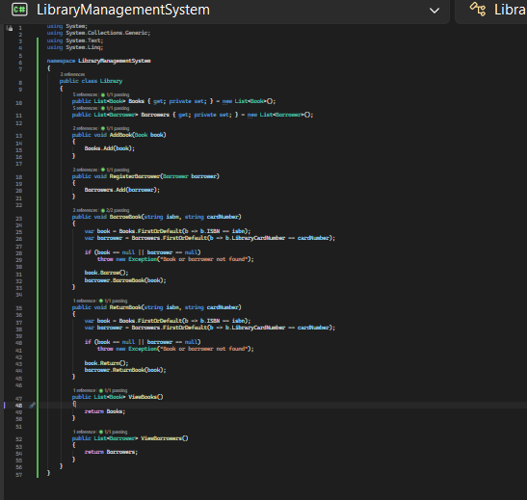

Unit Tests (NUnit):
using NUnit.Framework;
using LibraryManagementSystem;

namespace LibraryManagementSystem.Tests
{
[TestFixture]
public class LibraryTests
{
private Library library;
private Book book;
private Borrower borrower;

[SetUp]
public void Setup()
{
library = new Library();

book = new Book("Clean Code", "Robert Martin", "111");
borrower = new Borrower("Tushar", "CARD1");

library.AddBook(book);
library.RegisterBorrower(borrower);
}

// Add Book Test
[Test]
public void AddBook_ShouldIncreaseCount()
{
var newBook = new Book("Java", "James", "222");
library.AddBook(newBook);

Assert.That(library.Books.Count, Is.EqualTo(2));
}

//Register Borrower Test
[Test]
public void RegisterBorrower_ShouldIncreaseCount()
{
var b = new Borrower("Rahul", "CARD2");
library.RegisterBorrower(b);

Assert.That(library.Borrowers.Count, Is.EqualTo(2));
}

// Borrow Book Test
[Test]
public void BorrowBook_ShouldMarkAsBorrowed()
{
library.BorrowBook("111", "CARD1");

Assert.That(book.IsBorrowed, Is.True);
Assert.That(borrower.BorrowedBooks.Count, Is.EqualTo(1));
}

// Return Book Test
[Test]
public void ReturnBook_ShouldMakeAvailable()
{
library.BorrowBook("111", "CARD1");
library.ReturnBook("111", "CARD1");

Assert.That(book.IsBorrowed, Is.False);
Assert.That(borrower.BorrowedBooks.Count, Is.EqualTo(0));
}

// View Books Test
[Test]
public void ViewBooks_ShouldReturnList()
{
var books = library.ViewBooks();

Assert.That(books.Count, Is.EqualTo(1));
Assert.That(books[0].Title, Is.EqualTo("Clean Code"));
}

// View Borrowers Test
[Test]
public void ViewBorrowers_ShouldReturnList()
{
var borrowers = library.ViewBorrowers();

Assert.That(borrowers.Count, Is.EqualTo(1));
Assert.That(borrowers[0].Name, Is.EqualTo("Tushar"));
}
}
}
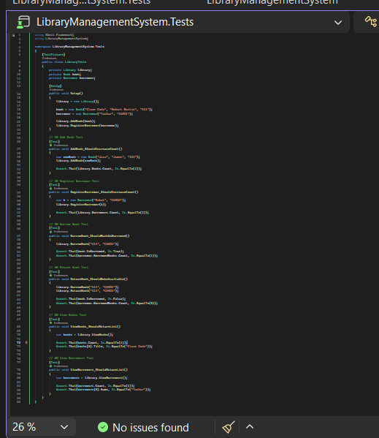

Test Results:
